**1.INTRODUCTION**

**Overview**

Flight planning is one of the challenges in industrial word which faces many uncertain conditions. One such conditions is delay occurrence, which stems from various factors and imposes considerable costs on airlines, operators, and travelers. Delay in departure can occur due to bad weather conditions, seasonal and holiday demands, airline policies, technical issue such as problems in airport facilities, luggage handling and mechanical apparatus, and accumulation of delays from preceding flights. Here in flight delay prediction system based on the weather parameters which can result in delays. The system considers the temperature, humidity, rain in mm, visibility and month number as important parameters for prediction of delay.Key words: Random forest, flight delay prediction.

**Purpose**

Data Collection: The first and foremost requirement is to collect data from various sources such as weather reports, airline schedules, airport operations, and any other relevant sources. This data is necessary to train machine learning models to predict flight delays accurately. Data Preparation and Preprocessing: Once the data is collected, it must be cleaned and pre-processed to remove any errors or inconsistencies. This process involves analyzing the data, identifying outliers, missing values, and correcting them. Also, the data must be transformed into a suitable format to fit into the machine learning model.

Furthermore, flight delay prediction can also benefit airline operations by allowing them to adjust schedules or allocate resources accordingly. This can help reduce the number of flight cancellations and overbooking, which can also increase customer satisfaction. Moreover, by predicting flight delays, airlines can improve their safety measures by ensuring that flights are not delayed due to

Furthermore, flight delay prediction can also benefit airline operations by allowing them to adjust schedules or allocate resources accordingly. This can help reduce the number of flight cancellations and overbooking, which can also increase customer satisfaction. Moreover, by predicting flight delays, airlines can improve their safety measures by ensuring that flights are not delayed due to unsafe weather conditions. This can help prevent incidents and accidents, and ultimately save lives.

Overall, flight delay prediction using machine learning can provide a positive social impact by increasing customer satisfaction, enhancing airline reputation, improving airline operations, and enhancing safety measures.

**2.Problem Definition & Design Thinking**

* **Empathy Map**

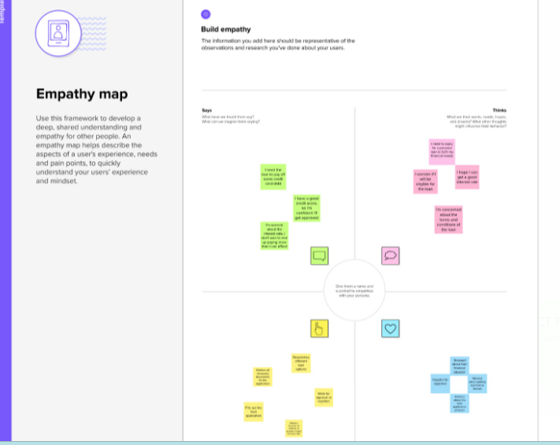

* **Ideation & Brinstorming map**

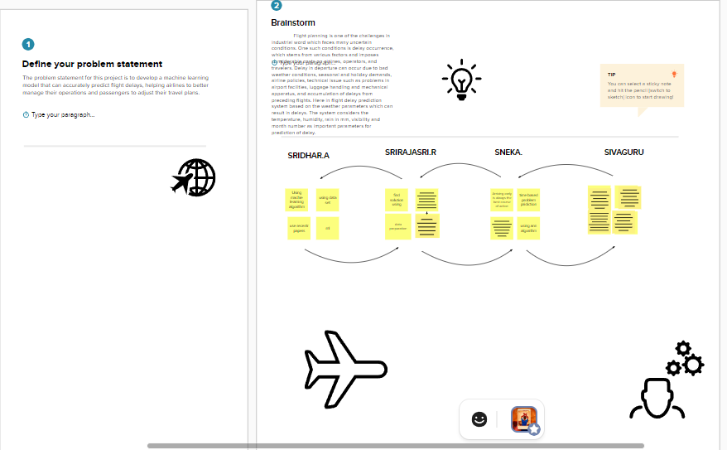

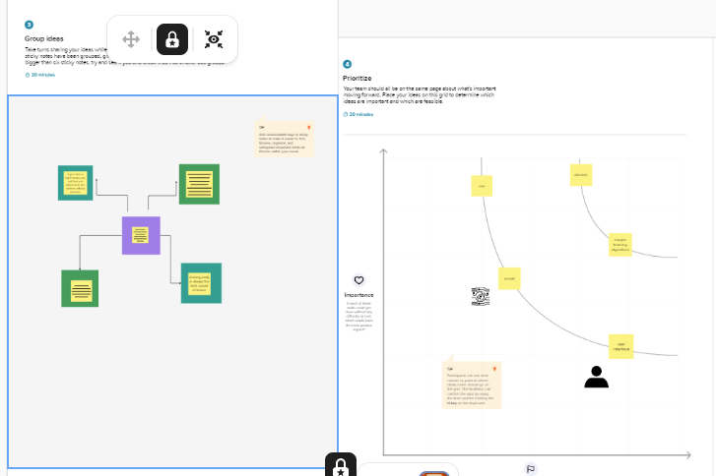

**3.RESULT**

**Result:1**

dataset=pd.read_csv(" flight data.csv")

dataset .head()

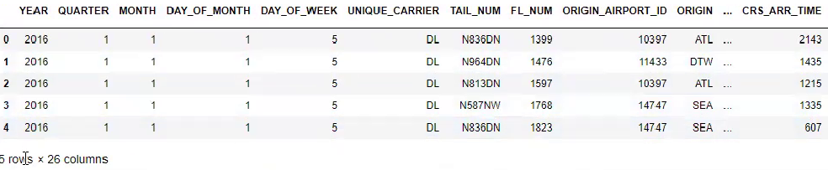

**Result:2**

dataset.isnull().any()

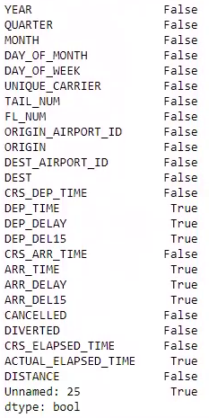

**Result:3**

dataset.colums

intex('YEAR','QUATER','MONTH','DAY_OF_MONTH','DAY_OF_WEEK','UNIQUE_CARTER','TAIL_NUM',FL_CCNUM','ORIGIN_ AIRPORD_ID','ORIGIN',DATE)



**Result:4**

dataset.isnull.sum()

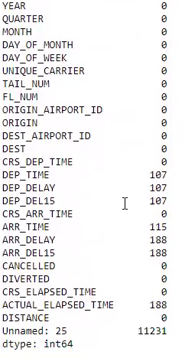

**Result:5**

flight_data=pd.red_csv(r"c:\user\user\dekdosp\download\11.flight delay prdiction

flight_data.desccribe()

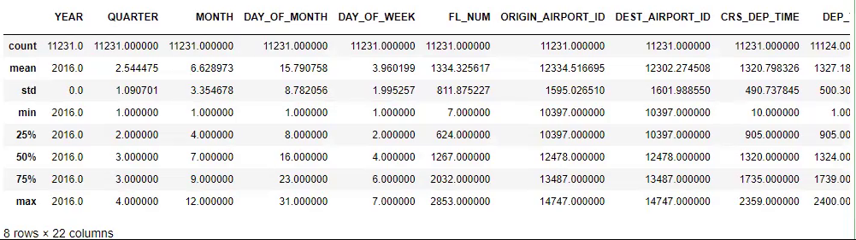

sns.scatterplot(x='ARR_DELAY',Y='ARR_DELIS',data=flight_data)

<Axessupbolt:xlabel='ARR_DELAY',ylabel='ARR_DELS15'>

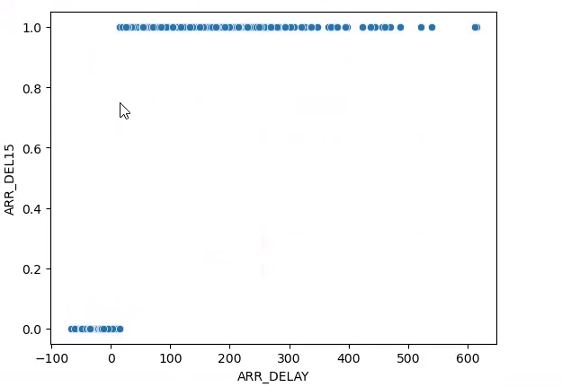

sns.caplot(x=:"ARR_DELS",y= "ARR_ DELAY",kind='bar',data=fliht_data)

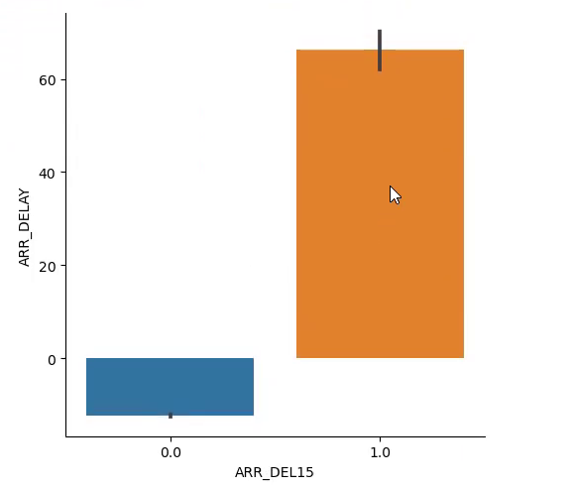

sns.heatmap(dataset.corr())

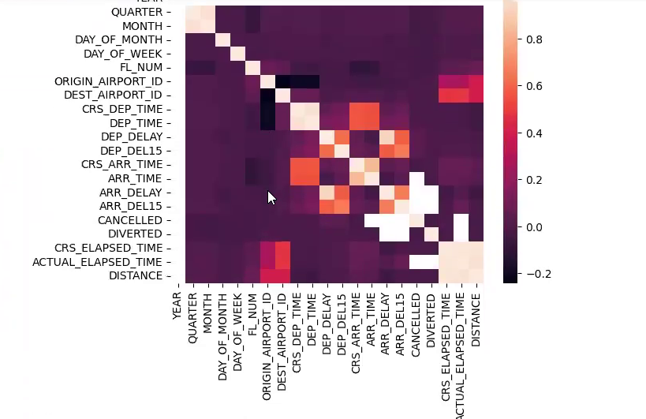

dataset=dataset[["FL_NUM',"MONTH","DAY _OF_MONTH", "DAY _OF_WEEK", ''ORIDGN'',''DEST'',''CRS_ARR_ TIME'',''DEP_ DELIS'',''DELS'']]

dataset.isnull().sum()

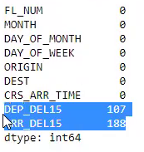

dataset[dataset.isnull().any(axis=1) ].head( 10)

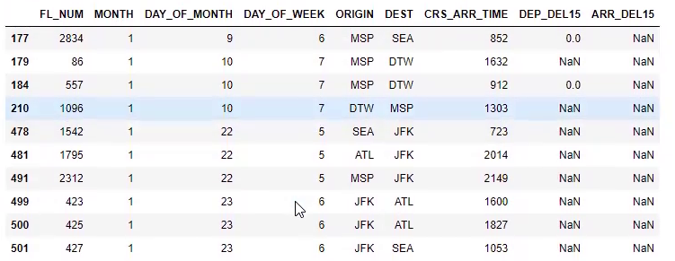

dataset['DEP_DELIS'].mode()

dataset=dataset.file.filine({'ARR_DELIS': 1})

dataset=dataset.file.filene({'DEP_DELIS':0})



import math

for index ,row in dataset.iterrows():

dataset.loc[index,'CRS_ ARR_ TIME']=math.floar(row['CRS_ARR_TIME']\100)

dataset.headC()



from skearn.preproescing import lable enoder

le=lableenccodcer()

dataset['DEST']=le.fit_tranfrom(dataset['DEST'])



dataset['ORIGHT'].unque()

arrary([0,1,4,2])

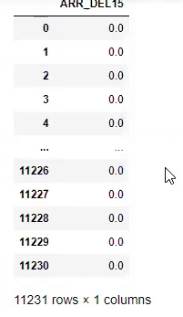

x=dataset.filoc[;:,0:c8]

y=dataset.filo[0:08]

y

array)([12567}]

{[65858}]

{788787]

[6878999[]dtybe=int64

x=

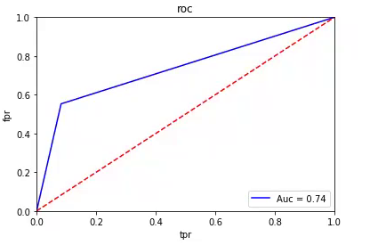

**4 ) ADVANDAGES**

Passengers: Flight delay prediction can provide passengers with information about potential flight delays, allowing them to adjust their travel plans accordingly. This can help prevent frustration and stress that may result from unexpected flight delaysAirlines: Airlines can benefit from flight delay prediction by being able to better manage their flight schedules and allocate resources more effectively. This can help reduce the costs associated with flight delays, such as compensation for affected passengers and crew, and can improve customer satisfaction.Airports: By predicting flight delays, airports can better manage their resources, including gates, runways, and personnel. This can help reduce congestion and improve efficiency, resulting in a more positive experience for both passengers and airlines.Air traffic controllers: Flight delay prediction can help air traffic controllers manage air traffic flow more efficiently, reducing the risk of flight delays and cancellations due to congestion or other operational issues.Aviation industry stakeholders: Predictive analytics on flight delays can help identify patterns and trends in flight delay occurrences, enabling stakeholders to identify and address potential root causes of delays and improve overall operational performance.

Overall, flight delay prediction can lead to improved efficiency, cost savings, and customer satisfaction for all stakeholders involved in the aviation industry.

**Top of Form**

**DISADVANDAGES**

Inaccuracy: Flight delay prediction models may not always accurately predict delays, especially in cases of unforeseen circumstances such as extreme weather events, mechanical issues, or unexpected air traffic congestion. This can lead to inconvenience and frustration for passengers and additional costs for airlines and airports.Privacy concerns: Predictive analytics on flight delays may require the collection and analysis of personal data from passengers, such as travel itineraries and booking information. This can raise privacy concerns and require careful management of data privacy policies.Bias: Flight delay prediction models may incorporate biases based on historical data or other factors, which could potentially result in unfair treatment of certain airlines, routes, or groups of passengers.Cost: Implementing flight delay prediction systems can be costly, requiring significant investment in technology, personnel, and data management. This may not be feasible for smaller airlines or airports with limited resources.Overreliance: Over-reliance on flight delay prediction systems may lead to complacency in operational decision-making and reduced preparedness for unexpected events, potentially leading to greater disruption in the event of a delay or cancellation.It's important to consider both the advantages and disadvantages of flight delay prediction when assessing its potential impact on the aviation industry. While the benefits can be significant, careful consideration and management of potential risks and challenges are essential for successful implementation.

**6.APPLICATION**

This can lead to inconvenience and frustration for passengers and additional costs for airlines and airports.Privacy concerns: Predictive analytics on flight delays may require the collection and analysis of personal data from passengers, such as travel itineraries and booking information. This can raise privacy concerns and require careful management of data privacy policies.Bias: Flight delay prediction models may incorporate biases based on historical data or other factors, which could potentially result in unfair treatment of certain airlines, routes, or groups of passengers.Cost: Implementing flight delay prediction systems can be costly, requiring significant investment in technology, personnel, and data management. This may not be feasible for smaller airlines or airports with limited resources.Overreliance: Over-reliance on flight delay prediction systems may lead to complacency in operational decision-making and reduced preparedness for unexpected events, potentially leading to greater disruption in the event of a delay or cancellation.It's important to consider both the advantages and disadvantages of flight delay prediction when assessing its potential impact on the aviation industry. While the benefits can be significant, careful consideration and management of potential risks and challenges are essential for successful implementation.

**7.CONCLUSION**

In conclusion, flight delay prediction is a valuable tool for the aviation industry, providing benefits for passengers, airlines, airports, air traffic controllers, and other stakeholders. By leveraging data analytics and machine learning algorithms, predictive models can help identify potential delays and enable more efficient allocation of resources and proactive management of operational issues.

However, it's important to recognize that there are potential disadvantages to implementing flight delay prediction systems, including inaccuracies, privacy concerns, biases, cost, and overreliance. These risks must be carefully managed to ensure that the benefits of predictive analytics are realized without compromising safety, security, or customer satisfaction.

Overall, flight delay prediction has the potential to transform the aviation industry by enabling greater efficiency, reducing costs, and improving the overall travel experience for passengers. As technology continues to advance and data analytics capabilities grow, flight delay prediction is likely to become an increasingly important tool for the aviation industry in the years to come.

**8.FUTURE SCOPE**

The future scope of flight delay prediction is vast, with ongoing advances in technology and data analytics likely to open up new possibilities for improving the accuracy and effectiveness of predictive models.

One area of potential growth is in the use of artificial intelligence (AI) and machine learning (ML) algorithms, which can help refine predictive models by analyzing vast amounts of data and identifying patterns and trends that might not be apparent through traditional statistical analysis. This could lead to more accurate and timely predictions of flight delays, as well as a better understanding of the underlying causes and potential remedies for such delays.

Another area of potential growth is in the integration of flight delay prediction with other aviation industry systems, such as air traffic control and airport management. By combining data from multiple sources, predictive models could be even more effective in identifying potential delays and enabling proactive management of operational issues.

In addition, there is potential for flight delay prediction to be integrated with other travel-related services, such as ride-sharing, hotel bookings, and ground transportation. By providing passengers with real-time information on potential flight delays, they can make more informed decisions about their travel plans and minimize disruptions to their overall travel experience.

Overall, the future scope of flight delay prediction is promising, with ongoing advancements in technology and data analytics likely to enable even more accurate and effective predictive models. This could help revolutionize the aviation industry by reducing costs, improving efficiency, and enhancing the overall travel experience for passengers.

**9.APPENDIX**